
Sukkur Institute of Business Administration University Department of Computer Science

Object oriented programming in Java BS – II Spring-2025

Lab # 3
Java Essentials Lab: Exploring Literals, operators, Javadoc and Arrays

Instructor: Nimra Mughal
Section BSCS Ai-B
Submitted By: Azhar Ali Soomro
CMS: 023-24-0521

Exercises
- Create two multi-dimensional(2d) arrays of size 4 by 4 and perform:
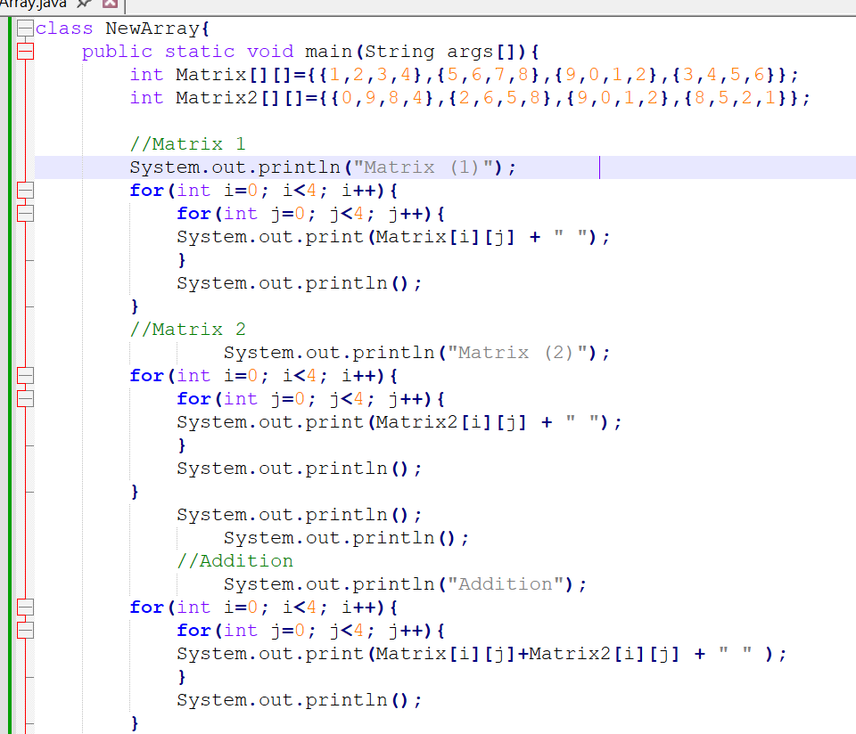
  - Matrix addition b. Matrix Multiplication c. Matrix subtraction
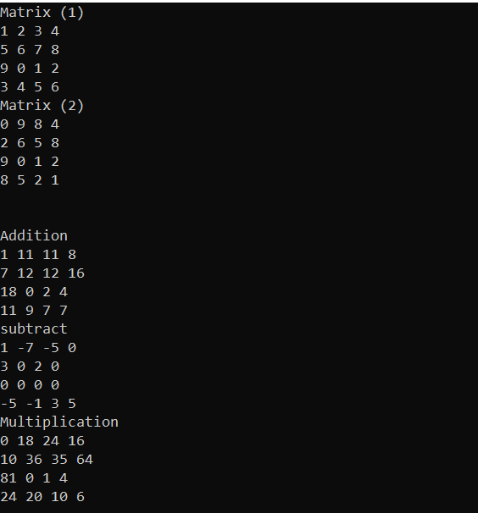
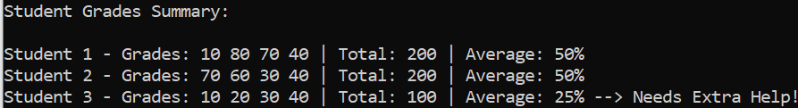
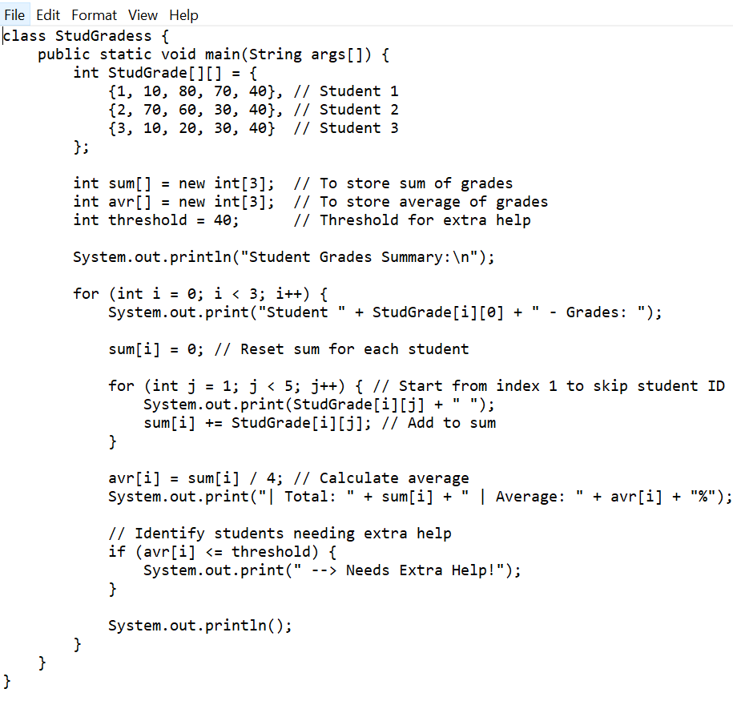
- You're creating a program to manage student grades for a class. How would you use a 2D array to store corresponding grades of students for multiple assignments? Explain how you would initialize the array, input grades, calculate averages for each student, and identify students who need extra help.
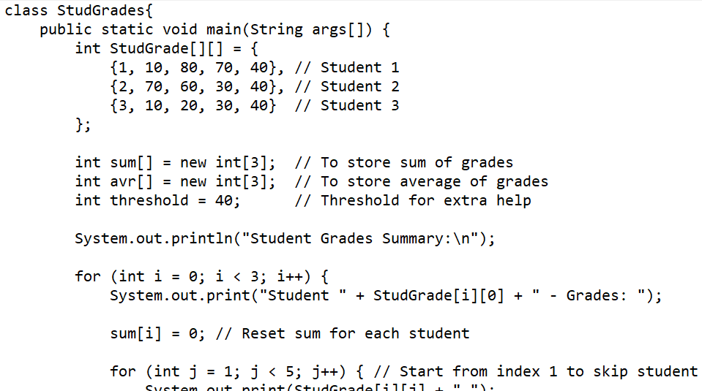
- You're tasked with creating a program to manage employee records for a company. How would you use a 2D array to store information such as employee IDs, and salaries? (Suppose the salaries are stores in the Integer type) Explain how you would create and initialize the array, search for employees by ID, and calculate statistics such as average salary. (please provide a java code) a. Use Hexadecimal notation for emploee ids.

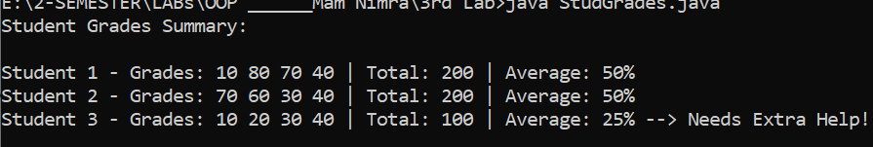

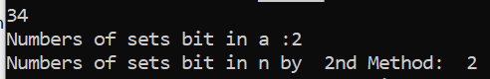
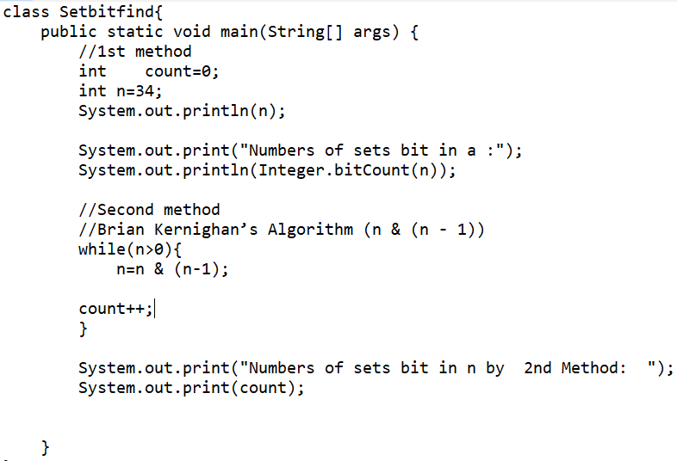
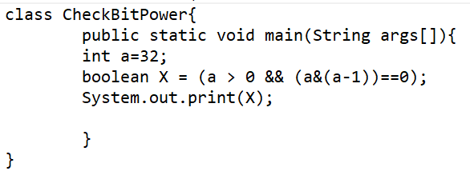
4. Bit Manipulation: Write a Java program to count the number of set bits (bits with value 1) in a given integer.
5. Check Power of Two: Write a Java program to check if a given integer is a power of two or not. Use bitwise operators for the check

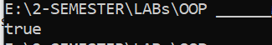
OUTPUT

6. Detect Odd or Even without Modulo Operator: Create a Java program to determine whether a given integer is odd or even without using the modulo (%) operator. Instead, use bitwise operators.
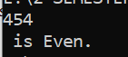
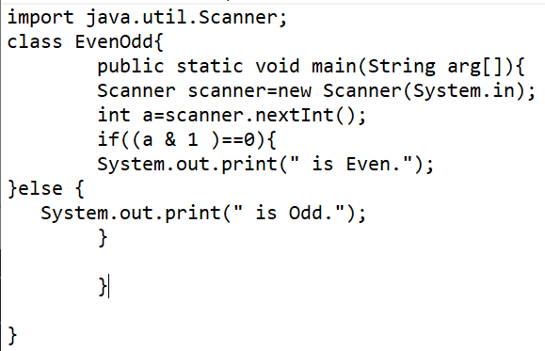

7. Write code that creates an array named odds and stores all odd numbers between 1 and 30 into it using a for loop
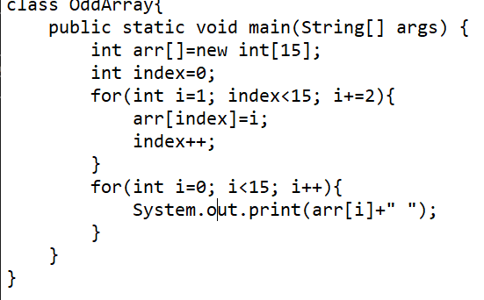

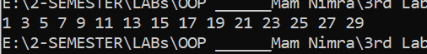

8. Calculate Hamming Distance: Write a Java a code to calculate the Hamming distance between two integers. Hamming distance is the number of positions at which the corresponding bits are different. Use bitwise operators to perform the calculation.
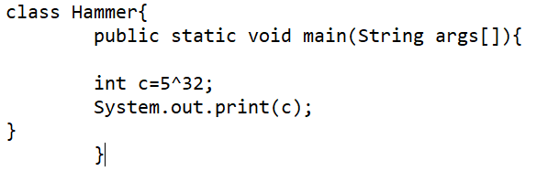
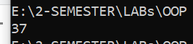

9 .Create a program to calculate the amount of tax owed based on income and tax brackets. In this task, you will develop a program that computes the amount of tax owed by an individual based on their income and a set of predefined tax brackets. Program will determine the tax owed by applying the appropriate tax rate to each portion of the income within the corresponding tax bracket and then summing up these amounts.
For this exercise, we'll use the following standard tax brackets and rates:
a. Income up to $10,000: Tax rate of 10%
b. Income from $10,001 to $20,000: Tax rate of 15%
c. Income above $20,000: Tax rate of 20%
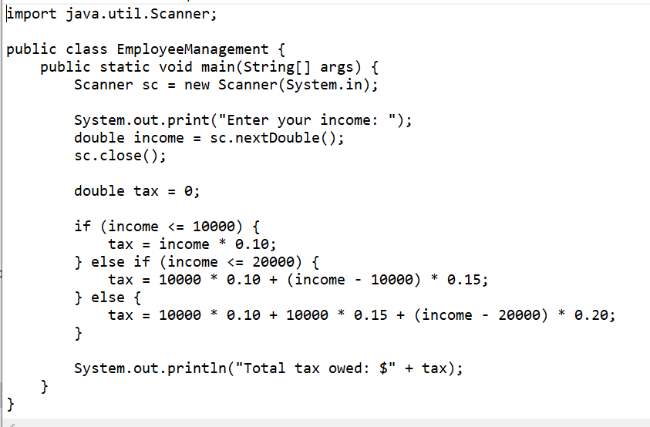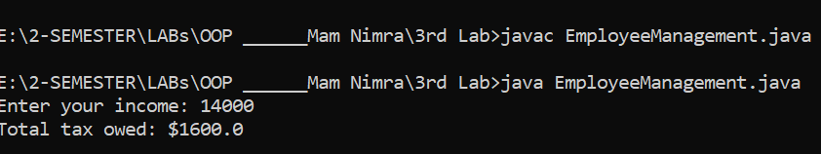
10. Create a class Person with fields for name, age, and address.
• Use @author and @version tags in the class comment.
• Use @PARAM and @return tags in method comments.
• Format comments with HTML tags for emphasis and lists (e.g., ).
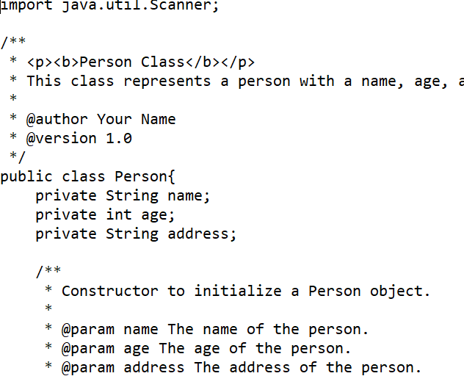
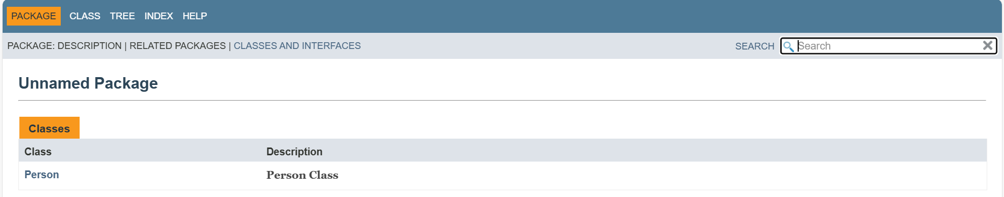
THE END

